**Title: Revolutionize your chip design with GDSFactory**

**Abstract**

GDSFactory is a powerful Python library for designing a wide range of complex systems, including photonic circuits, analog devices, quantum components, MEMs, 3D printed objects, and PCBs. With GDSFactory, you can create and refine your designs using Python or YAML, perform rigorous verification through Design Rule Checking (DRC), Layout Versus Schematic (LVS) checks, and simulations. Additionally, it facilitates automated lab testing to ensure that your fabricated devices meet precise specifications, streamlining the entire design-to-fabrication workflow.

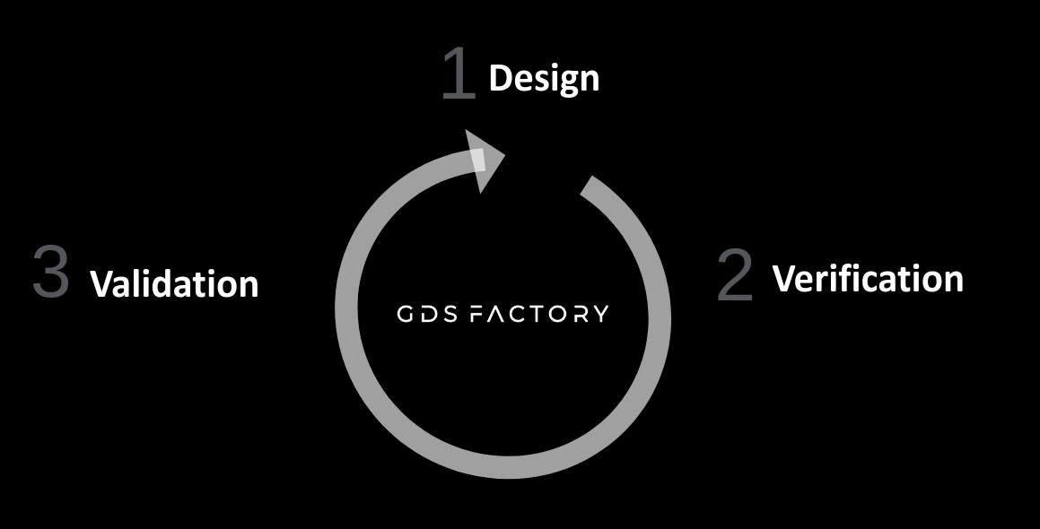

**Bio short**

Presenter bio: Joaquin is a veteran chip designer with 15 years of experience at top companies like Intel and Google X. He founded the successful open-source project gdsfactory in 2019, driving innovation in Python-based chip design with over 2 million downloads